

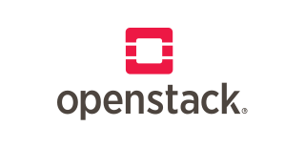

Explore

**OpenStack** is an open-source cloud computing infrastructure that provides common services for cloud infrastructure, including virtual machines, bare metal, and containers. [It allows you to manage large pools of compute, storage, and networking resources through APIs or a dashboard](https://www.openstack.org/) [1](https://www.openstack.org/)[2](https://www.openstack.org/software/)[3](https://ubuntu.com/openstack/what-is-openstack).

Here are **five free resources** where you can learn more about OpenStack:

1. [**OpenStack Official Website**](https://www.openstack.org/): Explore components, learn how to contribute, and find training resources.
2. [**Opensource.com**](https://opensource.com/resources/what-is-openstack): Discover articles and insights about OpenStack’s role in cloud computing.
3. [**Ubuntu’s OpenStack Page**](https://ubuntu.com/openstack/what-is-openstack): Understand OpenStack’s distributed compute, network, and storage management.
4. [**Red Hat’s OpenStack Guide**](https://www.redhat.com/en/topics/openstack): Dive into the core services of compute, networking, storage, identity, and image management.
5. [**edX OpenStack Courses**](https://www.edx.org/learn/openstack): Take online courses to deepen your knowledge of OpenStack [4](https://www.edx.org/learn/openstack)[5](https://www.classcentral.com/subject/openstack).

Happy learning! 🚀